

Έχω μια μικρή, τόση δα, ιδέα! Πάμε να κάνουμε τον γραπτό λόγο σου ακόμη καλύτερο.

**Κοίταξε τις εικόνες και πες ποιοι απ’ αυτούς τους ανθρώπους μπορεί να αισθάνονται μοναξιά. Έπειτα σκέψου τι θα μπορούσες να κάνεις για να τους βοηθήσεις.**

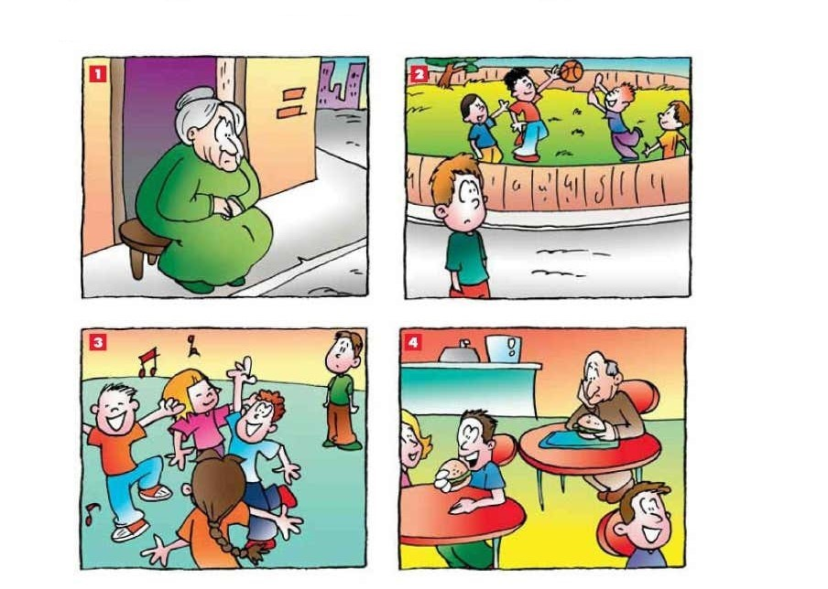

**Εικόνα 1**

**_____________________________________________________________________________________________________________________________________________________________________________________________________________________________________________________________________________________________________________________________________________________________________________________________________________________________________________________________________________________________________________**

**Εικόνα 2**

**_____________________________________________________________________________________________________________________________________________________________________________________________________________________________________________________________________________________________________________________________________________________________________________________________________________________________________________________________________________________________________________**

**Εικόνα 3**

**_____________________________________________________________________________________________________________________________________________________________________________________________________________________________________________________________________________________________________________________________________________________________________________________________________________________________________________________________________________________________________________**

**Εικόνα 4**

**_____________________________________________________________________________________________________________________________________________________________________________________________________________________________________________________________________________________________________________________________________________________________________________________________________________________________________________________________________________________________________________**