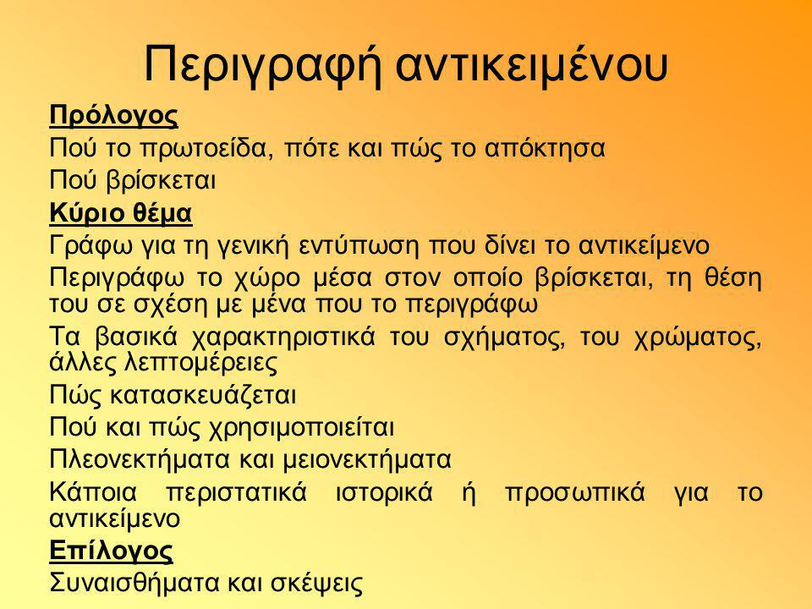

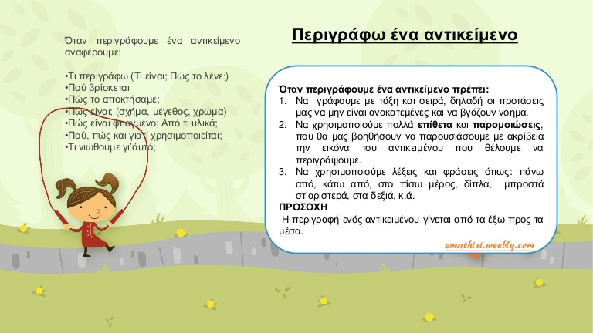

Αφού διαβάσεις τις παραπάνω εικόνες, διάλεξε ένα αγαπημένο αντικείμενο σου και περίγραψε το. Διάβασε προσεκτικά τι πρέπει να αναφέρεις και δώσε μου να καταλάβω πώς μοιάζει στην πραγματικότητα αυτό το αντικείμενο.

________________________________________________________________________________________________________________________________________________________________________________________________________________________________________________________________________________________________________________________________________________________________________________________________________________________________________________________________________________________________________________________________________________________________________________________________________________________________________________________________________________________________________________________________________________________________________________________________________________________________________________________________________________________________________________________________________________________________________________________________________________________________________________________________________________________________________________________________________________________________________________________________________________________________________________________________________________________________________________________________________________________________________________________________________________________________________________________________________________________________________________________________________________________________________________________________________________________________________________________________________________________________________________________________________________________________________________________________________________________________________________________________

Τέλος!!

