EASTER IN LIMNOS
If you visit Limnos during the Easter holiday, you must go to the beautiful church of Panagia Kakaviotissas. Located outside the village of Thanos , the church is built on a rock, and to the enter it you have to walk down a nature trail. It’s beautiful.
On the Good Friday, there is an animal-themed festival in the village of Kotsin, held at the church Zoodochou Pigis, where there is also a Holy Water fountain. Also all the Christ and bring it to the church so the priest can bless it. It is then passed out to the churchgoers.
On the evening of Resurrection, the locals light fire to barns and trees with the Holly Light for good luck. The traditional meal found in all the homes for the Resurrection of Christ is lamb in the oven, with a stuffing made of rice, raisins, sugar and cheese.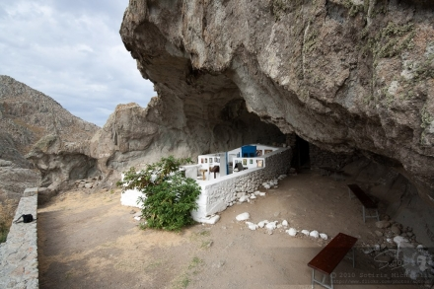

MARIANNA GIAPOUTZH, IOYLIA TSOLAKH KAI MARIA MPAKOYTSH E’1

