EASTER TRADITIONS IN TINOS
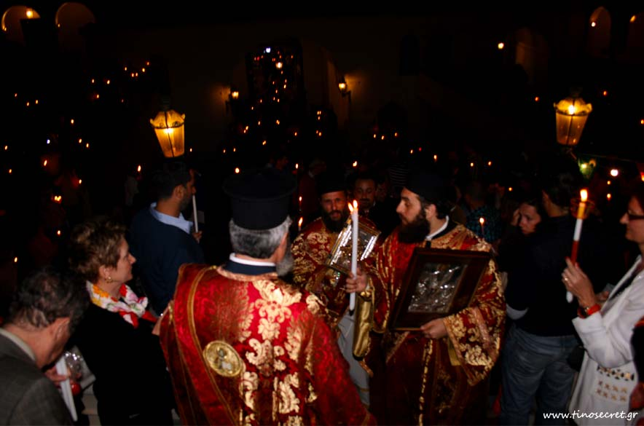
The morning of Holy Saturday marks the first Resurrection. When ‘Christos Anesti (Christ has risen ) the most important and joyful message of Christianity that sound out loud the defeat of Death- is announced by the priest, lemon leaves are scattered all over church and everyone is trying to catch one in the air and keep it for good luck and blessing. In the evening, just before the service of Resurrection white and red candles are distributed among the parishioners . When “Christos Anesti” is heard, excitedly chanted by the priest, bells start ringing and fireworks turning night into day. Then, fireworks called “trombones” take the lead.

From Efrosini , Zoe , Georgia

