Easter at the island of Patmos
by George, Konstantinos and Thomas

Palm Sunday
The people of Patmos make palm leaves that look like embroidery either in the shape of a cross or in the shape of a fish - they share them with the Christians of the island.

Holy Wednesday in Patmos
On Holy Wednesday, locals and visitors go to their parishes, to be blessed by the priest with the holy oil, to heal their soul and body.

Holy Thursday in Patmos
On the island of Patmos, every Holy Thursday at noon, people witness the revival of the ceremony when Jesus Christ washed the feet of His Disciples before the Last Supper. It takes place in Xanthou Square, in front of the town hall where the scene has been set up early. The roles of the 12 Apostles are played by monks or men of clergy and the role of Christ is played by the abbot of the Theologian Monastery, while the role of the Evangelist is played by a clergyman. The representation takes place in a strict monastic atmosphere.
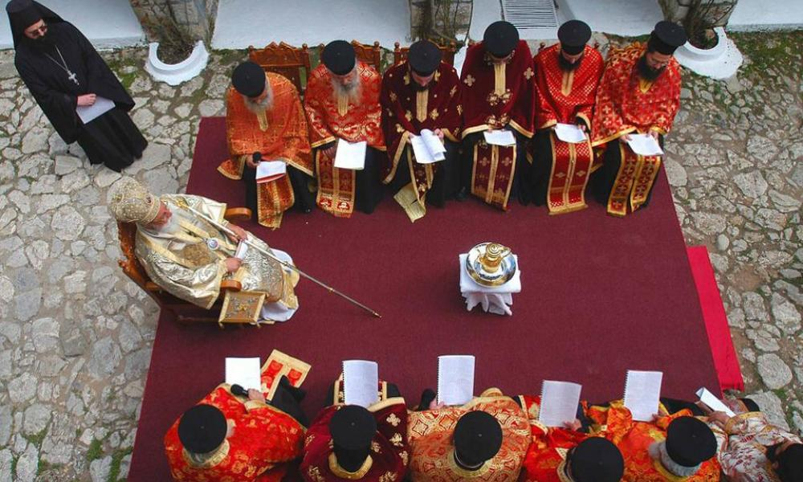

Easter Sunday in Patmos
The second Resurrection takes place on Easter Sunday and the Priest reads the Gospel in seven different languages. In Italian, German, French, English, Russian, Serbian and Ancient Homeric Greek. This is the Rite of Love

The end

