EASTER IN ZAKYNTHOS
In Zakynthos the celebration starts the night of Holy Thursday. The hymns sounded in church are inspired from Zakynthian church music. The basic difference with the other Greek places is that the Crucifix comes out after the eleventh Gospel and not after the fifth.
On Good Friday, the whole of Zakynthos participates in the Divine Drama. At noon on Good Friday, the culmination of the Zakynthian Holy Week takes place. In the Church of Saint Nikolas, the procession of the Crucified begins. Along with the Crucified One, the Icon of the Virgin of Passion is lit. The procession crosses the whole city and returns to the Square, where the first priest of the church blesses the clergy and the people with the Cross. After the procession, the Body of Christ is placed on the Epitaph (=the symbol of Holy Grave). At the Church, in the morning of Holy Saturday, the Resurrection procession begins from St. Mark's Square. This Sequence takes place in the early hours of Holy Saturday. On Easter Monday in many villages of the island a lot of traditional markets take place. In the afternoon in the city of Zakynthos an offertory of the idol of Panagia of Laourentenas happens.

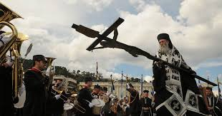
BY: BILLY, GEORGE AND KONSTANTINOS

